FIITJEE ADMISSION TEST

Class X

I.Q.

Time: 90 Minutes |  | Maximum Marks: 135

Instructions:

1. Attempt ALL the questions.
2. Answers have to be marked on the OMR sheet.
3. This Question Paper has only one part − PART–1 (45 questions)
4. The Question Paper contains blank spaces for your rough work. No additional sheets will be
provided for rough work.
5. Blank papers, clip boards, log tables, slide rule, calculator, cellular phones, pagers and
electronic devices, in any form, are not allowed.
6. Write your Name and Registration No. in the space provided at the bottom of this sheet.
7. All the questions are multiple choice questions having only one correct answer and each
question carries +3 marks for correct answer and -1 mark for wrong answer.

Name of the Candidate :

Registration Number :

PART − 1

1. If 7 × 5 × 4 = 57354 and 8 × 7 × 3 = 78563 then 6 × 8 × 5 = ?
(A) 86585 (B) 86855
(C) 68485 (D) 86485

2. Find the odd one out from the given alternatives:
(A) 94 – 7 (B) 42 – 6
(C) 35 – 5 (D) 56 – 8

3. Find the related word/number:
Suggest : Demand : : Take : ?
(A) Give (B) Grab
(C) Receive (D) Gift

4. Which is the odd number in the pattern given below?
4 | 32 | 144 | 17
28 | 122 | 18 | 64
322 | 14 | 602 | 24
(A) 4 (B) 17
(C) 28 (D) None of these

5. If 87654 stands for ‘GREAT’, then 754 stands for
(A) GET (B) TEA
(C) EAT (D) RAT

6. 1, 1, 2, 3, 5, 8, 13, ?
(A) 18 (B) 21
(C) 23 (D) None of these

7. 3, 4, 8, 17, 33, ?
(A) 58 (B) 45
(C) 49 (D) None of these

8. Find the missing number
1 | 4 | 9 | ?
1 | 2 | 3 | 4
2 | 4 | 6 | ?
(A) 36 and 4 (B) 25 and 5
(C) 16 and 8 (D) 49 and 7
9. $\frac{?}{}$ $\frac{?}{}$ab a $\frac{?}{}$$\frac{?}{}$ba $\frac{?}{}$ab
(A) abbba (B) abbab
(C) baabb (D) bbaba

Space For Rough Work

Directions (10-14): Each of the following questions has three rows of figures. From the third row, one figure is missing. The missing figure is one of the five alternative figures given at the end of each question. Find the missing figure.
10. | 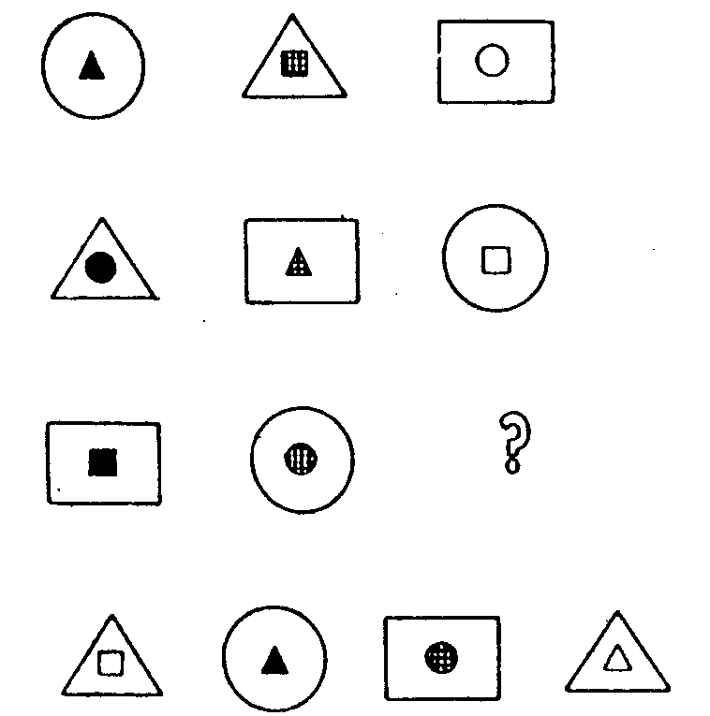
 |  | (A) | (B) | (C) | (D)

11. | 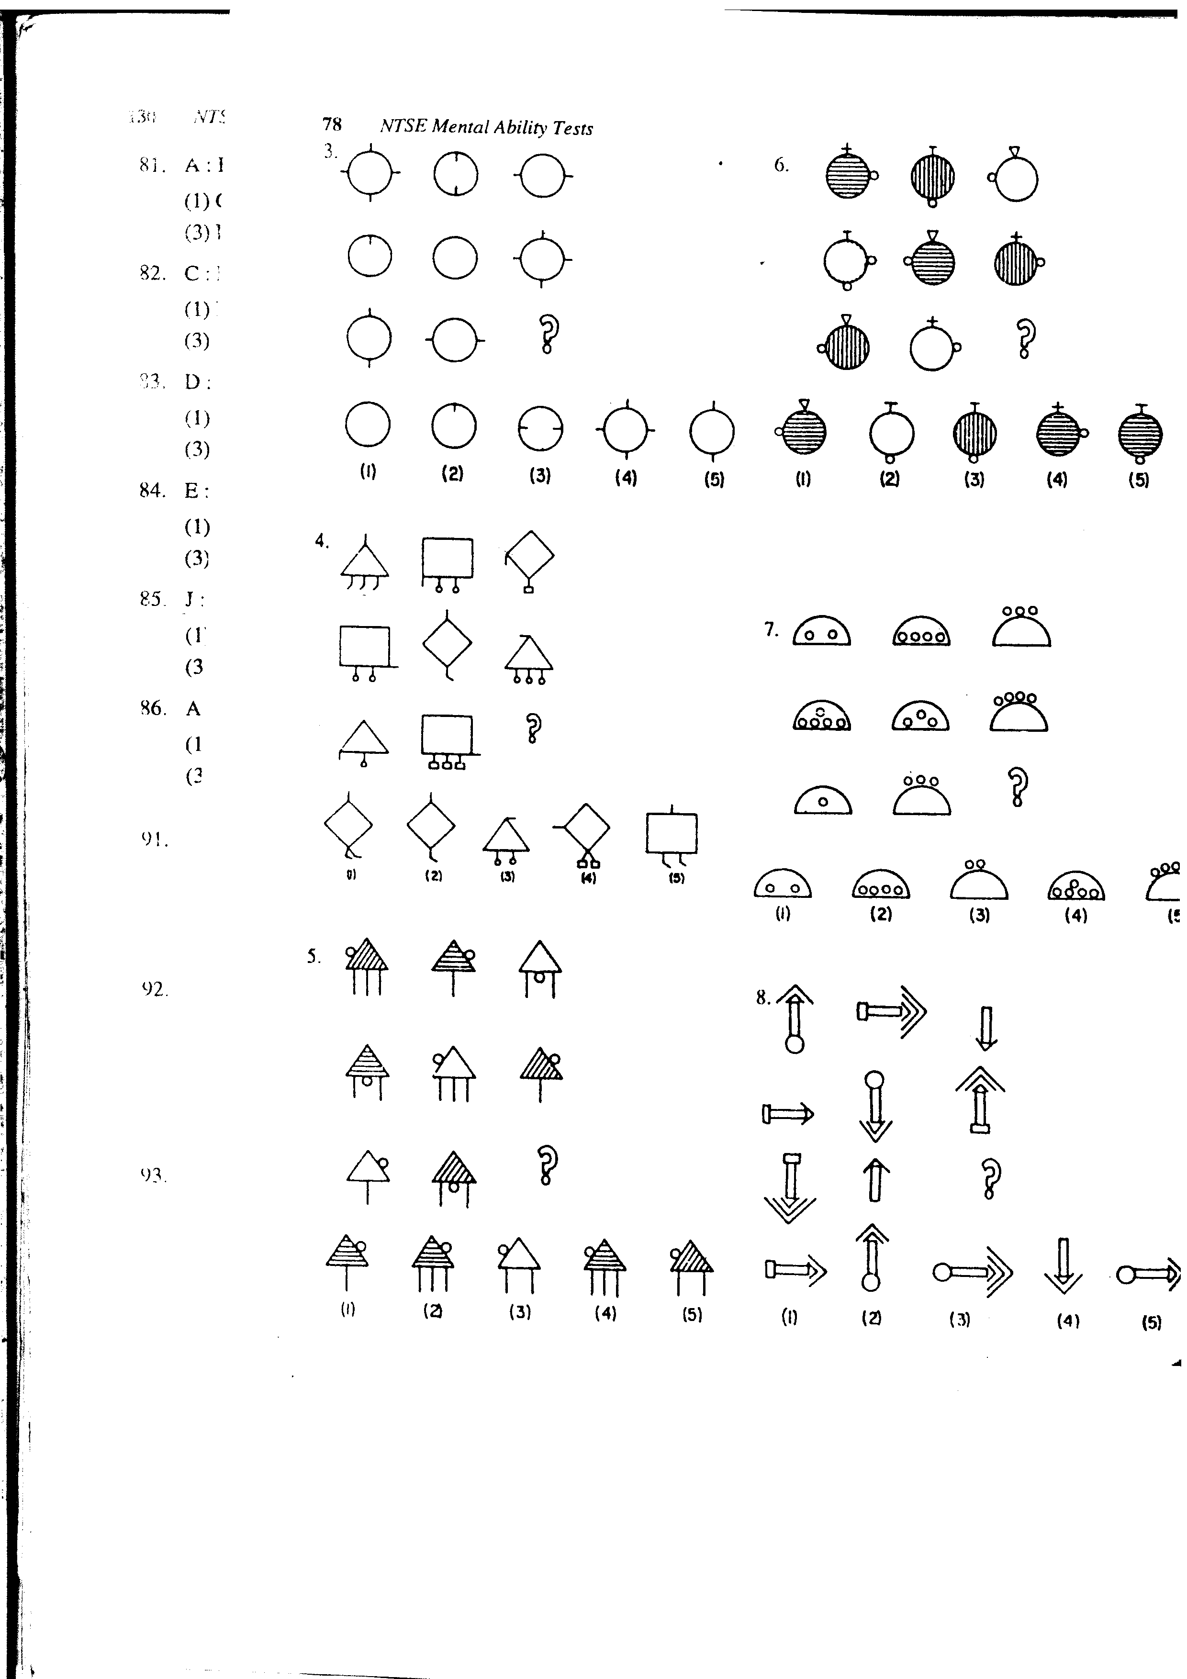
 | (A) | (B) | (C) | (D)

12. | 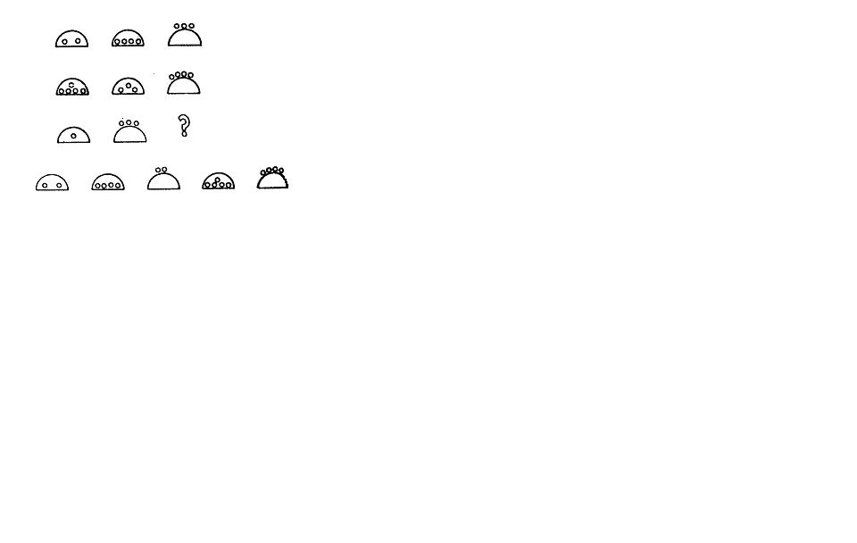
 |  | (A) | (B) | (C) | (D)

Space For Rough Work

13.
 | (A) |  | (B) | (C) | (D)

14.
 |  | (A) | (B) | (C) | (D)

Directions (15−16): In each of the following questions one or more statements have been given followed by four inferences, A, B, C and D. Find out the inference that definitely follows from the given statement.

15. “Soldiers serve their country”.
A. Those who serve their country are soldiers
B. Women do not serve their country because they are not soldiers
C. Men generally serve their country
D. Some men who are soldiers serve their country.
16. “Most of the pens in that shop are expensive”.
A. There are no cheap pens in that shop
B. Some of the pens in that shop are expensive
C. There are cheap pens also in that shop
D. Camlin pens in that shop are expensive.

17. Look at the figure given below:
Which number is on the face opposite to 6?
(A) 5 (B) 3
(C) 1 (D) 4

Space For Rough Work

18. The next digit in the series 6, 4, 3, 12/5, will be:
(A) 7/3 (B) 9/4
(C) 13/5 (D) 2

19. In the following question, the wrong term and its substitution by the correct term are indicated as a pair in the four options to each question. Identify the correct pair.
24, 49, 99, 94, 15, 31, 59, 58
(A) (49, 47) (B) (99, 95)
(C) (94, 101) (D) None of these.

Directions (20−22): In each of the questions given below, there is a letter group series with one term missing as shown by (?). This term is given as one the alternatives among the groups of letters given under it. Find this term.

20. (?), PSVYB, EHKNQ, TWZCF, ILORU
(A) BEHKN (B) ADGJM
(C) ZCFIL (D) IMPSV

21. ACMYA, FHNDF, (?) PRNNP, UWMSU, ZBNXZ
(A) INMKI (B) KMNIK
(C) IMNKI (D) KMMIK

22. BASTU, (?) DCQVW, DEPXW, FEOXY, FGNZY
(A) CBTUT (B) CBRUV
(C) BCRVU (D) BCTVU

Directions (23−25): In the questions given below there are four terms, one of which is missing as shown by (?). Two terms to the left of : : bear the same relationship as the two terms to its right. Find the missing term from among the five alternatives given at the end of each question.

23. ? : JKHI : : TURS : OPMN
(A) MNOP (B) LMNO
(C) OPMN (D) NLMO

24. AEFJ : KOPT : : ? : QUVZ
(A) GLKP (B) GKLP
(C) HKLP (D) HKQL

25. ACEG : ? : : BDFH : KMOQ
(A) NLPR (B) LMNO
(C) JLNP (D) JNLO

26. A rat runs 20 m towards east and turns to right, runs 10 m and turns to right, runs 9 m and again turns to left, turns to left, runs 5 m and then turns to left, runs 12 m and finally turns to left and runs 6 m. Now which direction is the rat facing?
(A) East (B) North
(C) West (D) South

27. Mehrunisa is the 11th from the either end of the row of girls, how many girls are there in that row?
(A) 19 (B) 20
(C) 21 (D) 22

Space For Rough Work

Directions(28−30): Choose the correct alternative.

28. If ‘PAINTER’ is coded as ‘3528617’ which is the correct code for ‘TANRPEI’?
(A) 6587312 (B) 6583721
(C) 6587132 (D) 6583712

29. ‘PLANETS’ is coded as ‘4823579’. Which is the correct code for ‘SNLEPAT’?
(A) 9385247 (B) 9384527
(C) 9385427 (D) 9385742

30. If ‘MADRAS’ is coded as ‘56’, how can ‘CALCUTTA’ be coded
(A) 8 (B) 38
(C) 81 (D) 76

Directions (31−34): In a certain code ‘I received a letter’, means ‘we saw an aircraft’. ‘Shyam received one too’ means ‘the aircraft is blue’, ‘Shyam loves long letters’ means ‘captain saw blue flag’ and ‘I like long one’ means ‘we believe the captain’.
The questions are based on the above information.

31. What does the word ‘received’ in the code mean?
(A) we (B) saw
(C) blue (D) aircraft

32. Which word is coded as ‘believe’?
(A) received (B) saw
(C) loves (D) like

33. What is the code for ‘long letter’?
(A) Shyam loves (B) captain saw
(C) I like (D) we believe

34. What is the code for ‘the captain’?
(A) long one (B) long letter
(C) received one (D) saw flag

35. If sign ‘–‘ means ‘plus’, sign ‘+’ means ‘minus’, sign ‘×’ means ‘divided by’ and sign ‘÷’ means ‘multiplied by’, then simplify:
7 – 8 × 5 ÷ 6 + 4
(A) 3 (B) 12
(C) (D)

36. If ‘+’ stands for ‘division’, ‘–‘ stands for ‘equal to’, ‘×’ stands for ‘addition’, ‘÷’ stands for ‘greater than’, ‘=’ stands for ‘less than’, ‘>’ stands for ‘multiplication’ and ‘<’ stands for ‘subtraction’, then which of the following alternatives is correct?
(A) 5 + 2 × 1 = 3 + 4 > 1 (B) 5 > 2 × 1 – 3 > 4 < 1
(C) 5 × 2 < 1 – 3 < 4 × 1 (D) 5 < 2 × 1 ÷ 3 > 4 × 1

37. A person goes 2 kms towards East. He then turns right and goes 1 km. He turns again right and goes 3 kms straight. In which direction is he now from his starting place?
(A) North-East (B) North-West
(C) South-East (D) South-West

Space For Rough Work

38. Ram travels 4 kms towards North, then he turns 45° South-East and travels 2 kms. From there, he makes a bee-line towards his starting point. In which direction would he then be travelling?
(A) South (B) West
(C) South-East (D) South-West

39. The number of circles in the figure given will be
(A) 10 (B) 11
(C) 12 (D) 13

40. The number of squares formed in the figure given will be
(A) 8 (B) 10
(C) 12 (D) 14

Directions (41-45): Choose the correct alternative:

41. Calf: Cow :: Infant: ?
(A) Adult (B) Adolescent
(C) Animal (D) Child

42. Drop: Ocean :: Star:?
(A) Sky (B) Shine
(C) Twinkle (D) Bright

43. :?
(A) (B)
(C) (D)

44. Head: Cap :: Finger:?
(A) Nail (B) Helmet
(C) Ring (D) Thumb

45. Feet : Shoes :: Hands:?
(A) Finger (B) Arms
(C) Gloves (D) Watch

Space For Rough Work
FIITJEE ADMISSION TEST

Class − X

IQ
ANSWERS
PART − 1
1. D 2. A 3. B 4. B
5. D 6. B 7. A 8. C
9. B 10. D 11. A 12. A
13. B 14. B 15. A 16. C
17. D 18. D 19. B 20. B
21. D 22. C 23. C 24. B
25. C 26. B 27. C 28. A
29. C 30. C 31. D 32. D
33. B 34. A 35. C 36. B
37. D 38. D 39. D 40. B
41. A 42. A 43. B 44. C
45. C

